**Docker Compose**

Created two files: evs.env and docker-compose.yml



We can see our docker container is not running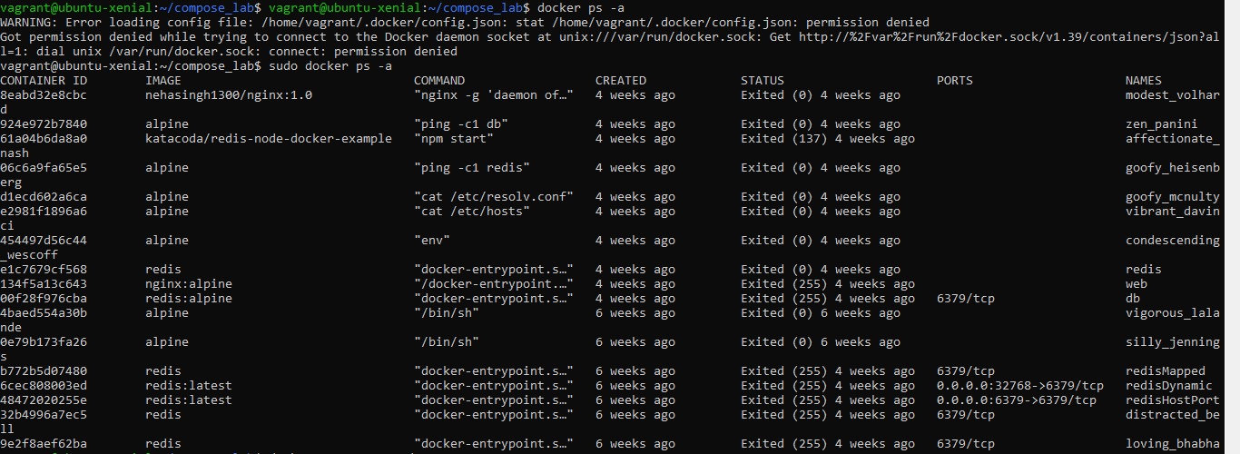

Pulling required images from docker hub.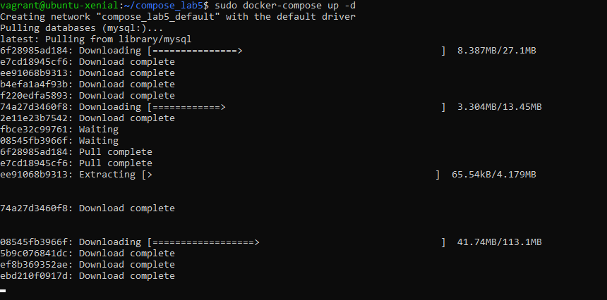

Now, you can see NGNIX and mysql server started 2 min ago.